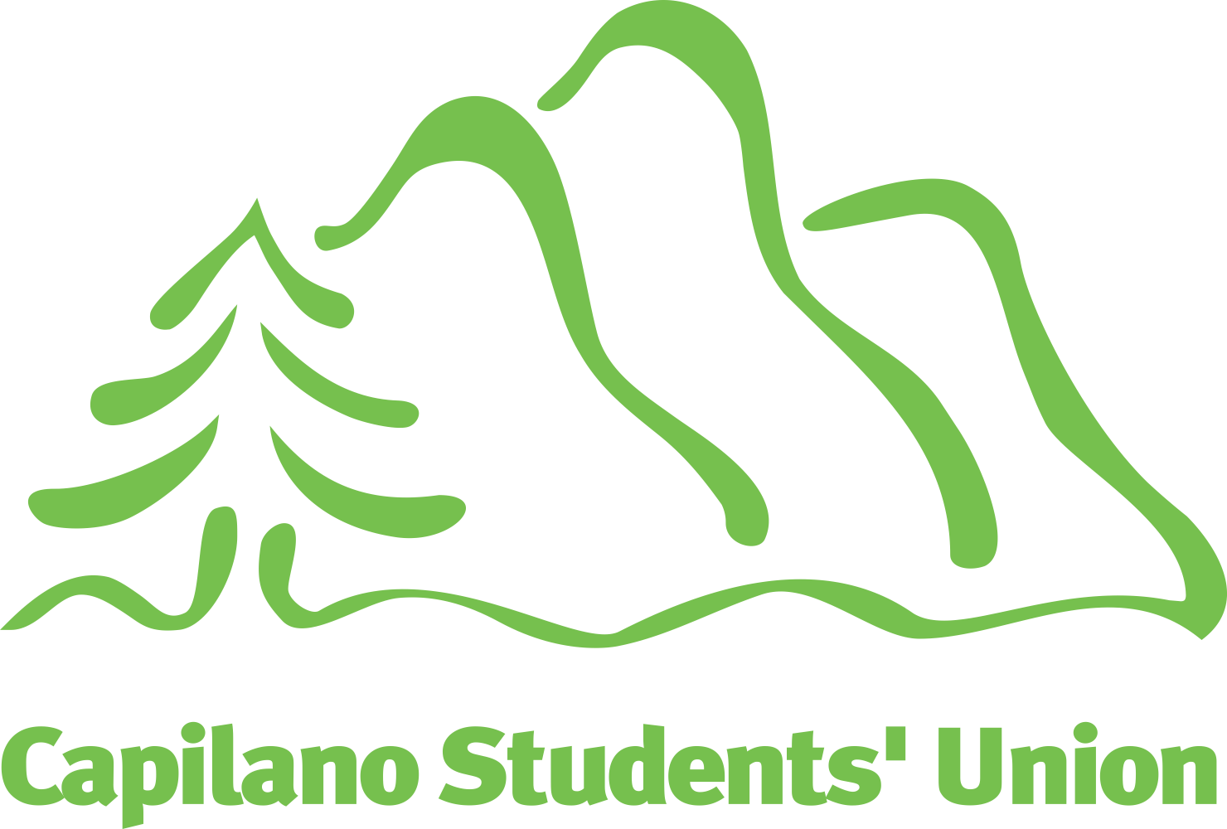
Capilano Students’ Union

Presented at the Annual General Meeting (October 22, 2020)
Report of the Board

Members of the Capilano Students’ Union,
Welcome to the 2020 annual general meeting!
The Capilano Students’ Union is an exciting and dynamic organization where elected student leaders get to work together with a team of dedicated staff to make sure that our members have the best possible student experience at Capilano University.
We’ve been working especially hard in the context of the ongoing public health emergency to make sure that all of our services are still available to you while you attend CapU remotely including our Community Cupboard, Device Doctor, and advocacy services. As well as regularly meeting with the university administration around issues of academic support, their COVID-19 response, and access to well-being services for all of our members.
If you haven’t connected with us through the Capilano Quarantine Corner yet, or through our Instagram @capstudentunion, I encourage you to do so! It’s the best way to stay informed on all of the exciting things we’re working on this year.
We’re also hiring a few staff positions that are open only to Capilano University students! Are you interested in being a part of our team? You can apply here for a number of positions and work for a supportive organization while making a living wage.
Lastly, I want to reiterate some of the sentiments I shared in my address at the beginning of this year - attending post-secondary right now, in the context of a tumultuous global community is difficult, to say the least. I recognize and acknowledge each one of you for your dedication, courage, and tenacity during this time. I know navigating the world right now is exhausting, and while the CSU can’t support you with everything that’s happening in your life, we’re here to support you in your time at CapU. As students, we are isolated but not alone.
Thank you for attending the general meeting - we couldn’t do the work that we do without the support and engagement of our members — the students of Capilano University.
Yours Sincerely,
Emily Bridge
President
The work of the Capilano Students’ Union would not be possible without the people who make up our team. As a student association, the Capilano Students’ Union is led by a board of passionate student leaders who provide leadership, oversight, and who determine the direction of the organization; they’re supported by a team of professionals who carry out the board’s decisions and policies.

Board
Emily Bridge President
Shanti Scarpetta-Lee VP Equity & Sustainability
Grace Dupasquier VP External
Gurleen Kaur VP Finance & Services
Hartaj Wadhwa VP Student Affairs
Feven Kidane Students of Colour Liaison
Abhijeet Deswal International Students Liaison
Maia Lomelino Women Students Liaison
Mayumi Izumi Mature & Parent Students Liaison
Brigid Mychael kálax-ay | Sunshine Coast Campus Representative
Gurkirat Singh Arts & Sciences Representative
Neerarshdeep Kaur Business & Professional Studies Representative
Trevor Morten At-Large Representative
Oscar Blue Board of Governors (Capilano University)
Alea Rzeplinski Senate (Capilano University)
Theodore Abbott Senate (Capilano University)

Staff
Gurleen Aujla Frontline Operations Assistant
Kelsi Boroevich Recreation & Wellness Coordinator
Jimena Camarena Administrative Assistant
Donna Cole Director, Student Associations (on leave)
Abby Cunningham Indigenous Resource Coordinator
Kristi De Wolf Equity Conference Coordinator
Jessica De Gaust Office Coordinator
Allan de Jesus Director, Technical Services
Saulo Ferreira Financial Controller
Christopher Girodat Executive Director
Kate Jarman Director, Student Spaces
Lori Kosciuw Director, Advocacy
Ann Luo Director, Programs
Hassan Merali Director, Student Associations
Argel Monte de Ramos Outreach Assistant
John Morrison Director, Communications
Trina Pacana Member Services Assistant
Clarice Scop Research Assistant
Joshua Thomas Director, Policy & Campaigns

Introduction
The Capilano Students’ Union advocates to the university, all levels of government, and other agencies (such as TransLink and BC Transit) to improve learning and living conditions for students. This work happens through action and awareness campaigns, and also through direct advocacy with university and government decision-makers.
This year, our approach to campaigns had to adapt to the public health emergency, meaning much more of a focus on social media engagement and online meetings with policy-makers, and nearly no resources toward on-campus student awareness activities. Most of our interactions with the university have been focused on ensuring that students’ rights and interests are protected during the switch to remote learning. This report summarizes the current campaigns of the Capilano Students’ Union.

Affordability Campaigns

Cap International Tuition
International students have been disproportionately affected by the public health emergency, with some students not even able to enter Canada during their first academic term; this means that it is more important than ever to address the fact that neither the provincial government nor the university have any policies in place limiting annual increases to international student tuition. (Domestic students’ tuition fees, on the other hand, can only be increased by two percent under provincial policy.)
While Capilano University has voluntarily maintained the practice of limiting international student tuition increases to the same percentage by which domestic student tuition is increased, this is only a practice, and not a policy. The Cap International Tuition campaign calls on the university to establish a policy that caps increases to international student tuition at two percent per year, so that international students have certainty when planning their time at Capilano University.

Make the Switch
The Capilano Students’ Union has been meeting regularly with the university’s Centre for Teaching Excellence to encourage faculty members to “Make the Switch” to open educational resources: free, online, open-source textbooks. This is one way that every individual instructor at Capilano University can have a direct impact on affordability.
Capilano University students have already saved over $160,000 from instructors who have made the switch to open educational resources so far. If you’re interested in seeing this number grow, here are some ways that you can help right now:
- Post your textbook receipts on social media, tagging @capstudentunion and #MakeTheSwitch, and tell the university how making the switch would help you.
- Talk to your instructor about making the switch by using our email template.

Awareness Campaigns

I ❤ Consent
The Capilano Students’ Union and Capilano University have partnered to develop the “I ❤ Consent” campaign to educate members of the university community on how to practice and promote consent, to challenge rape culture, and to support survivors.

Take It Over
Advanced education policy — government rules that govern how post-secondary institutions, including Capilano University, are run — are under provincial jurisdiction, and British Columbia is in the midst of a provincial general election. The Capilano Students’ Union has partnered with other student societies from across the province, the Alliance of BC Students, and the BC Federation of Students to run a voter mobilization campaign to ensure that the student vote has an impact on the provincial general election.
Take the pledge to vote today.

Relations with Government
Every year the Capilano Students’ Union meets with federal, provincial, and local policy-makers to ensure that the interests of Capilano University students are front-and-centre when making decisions affecting post-secondary educational policy.
This year, we have had to approach relationship-building differently, given the unique circumstances brought by the pandemic. We have had over a dozen meetings with federal, provincial, and local decision-makers to advance students’ interests.

Provincial
The Capilano Students’ Union meets regularly with provincial officials to influence post-secondary educational policy and other provincial issues affecting students. Much of our work on the provincial stage is undertaken in partnership with the Alliance of British Columbia Students, our provincial student advocacy group.
Mental Health Supports: The Capilano Students’ Union has met with several Members of the Legislative Assembly to discuss the need for additional mental health support for students, especially during the pandemic where social isolation is heightened. These asks have included additional funding for on-campus counselling services.

Federal
While universities themselves fall within provincial jurisdiction, there are a number of issues that interface with students’ interests that are within the jurisdiction of the federal government, and so the Capilano Students’ Union meets regularly with federal officials on student issues. A lot of our federal advocacy work is done in concert with our colleagues at the Canadian Alliance of Student Associations.
COVID-19 Response: The Capilano Students’ Union has met with several Members of Parliament (including two ministers’ offices) to lobby for improved support for students who are struggling to make ends meet during the pandemic, including attempting to secure additional financial assistance for students by redirecting the funds that had previously been committed to the Canada Student Service Grant. We also encouraged the government to reconsider eligibility for the Canada Emergency Student Benefit so that international students could also receive access to benefits.
International Student Working Hours: The Capilano Students’ Union met with Jonathan Wilkinson, Member of Parliament for North Vancouver, to discuss easing up restrictions that the federal government places on the allowable working hours for international students (who are currently restricted to working 20 hours per week off-campus). Given the price of post-secondary education, and the fact that international student tuition is unregulated, the ability of an international student to earn reasonable income is critical.
Indigenous Sovereignty and Climate Advocacy: The Capilano Students’ Union met with the Minister of the Environment and Climate Change to discuss students’ opposition to the Trans Mountain Expansion Project, and to demand that the federal government respect the governance systems of the Wet’suwet’en hereditary chiefs.
The Capilano Students’ Union signed a letter to the federal government authored by our colleagues at the Simon Fraser Student Society, alongside over a dozen other student associations from across the country, calling on the government to cancel the Trans Mountain Expansion Project due to violations of Indigenous sovereignty, and the potentially devastating environmental impacts.

Local
The Capilano Students’ Union meets with local mayors and councillors to ensure that students’ needs are being considered at the municipal level. These discussions include public transit, and feedback on the development of student housing projects.

Transit Authorities
The Capilano Students’ Union meets regularly with officials from TransLink, and with Bowinn Ma, the Parliamentary Secretary for TransLink, to ensure that students have access to effective and affordable public transit services.
U-Pass BC Program: Student associations and post-secondary institutions throughout Metro Vancouver were faced with challenging decisions around how to address the U-Pass BC program during the pandemic. For the summer semester, when the province had implemented its most restrictive movement rules, the U-Pass BC program was suspended; the program resumed on September 1.
245 Phibbs Exchange / Capilano University: The Capilano Students’ Union was consulted closely by TransLink on planning the new 245 route between Phibbs Exchange and Capilano University, and we had secured a frequency of as often as every four to five minutes during peak hours. However, those plans have been disrupted by the pandemic. We continue to have regular discussions with contacts at TransLink to monitor how the new (and temporarily reduced) frequency is meeting students’ needs.

Relations with Capilano University

Senior Administration
The Capilano Students’ Union meets regularly with the university administration to advocate for students. This year, our discussions have been centred on the concerns of students during the university’s transition to remote and adapted learning.
University Executive: Our executive team meets with the university executive once per month to discuss student issues. We have used this forum to regularly convey students’ concerns about student support services, academic quality in the switch to remote and adapted learning, and other pandemic-related issues.
COVID-19 Check-ins: In addition to our monthly meetings with the full university executive, we also established weekly meetings with select university vice-presidents to discuss the university’s COVID-19 response as it was happening. These meetings have now been reduced to a bi-weekly frequency during the fall term.

Board of Governors
The university board of governors is the senior governing body for the business of Capilano University. Select executives and staff of the Capilano Students’ Union attend meetings of the board to stay informed on key decisions that might affect students. Student members of the board of governors are also invited to serve on the Capilano Students’ Union board of directors in an ex officio capacity.
Sexual Violence Policy: The Capilano Students’ Union encouraged the board of governors to approve a more progressive and modern sexual violence policy that would call for more education for faculty, staff, and administrators on consent culture and responding appropriately to disclosures of sexual violence.
COVID-19 Response: The Capilano Students’ Union encouraged the board of governors to provide high-level governance leadership in encouraging academic leadership to provide a compassionate and accommodating academic response to the pandemic.

Senate & Academic Issues
The university senate is the senior academic governing body of Capilano University, setting curriculum, grading profiles, and other academic matters. The four student senators also serve on the Capilano Students’ Union board ex officio, and the Capilano Students’ Union also sends a permanent guest to speak at the senate table.
Pass/D/Fail: The Capilano Students’ Union encouraged Capilano University to provide academic accommodations to students impacted by the public health emergency, including the option to take a “pass” (without a GPA impact) on courses during the term in which the pandemic had begun, acknowledging that many students’ academic performance were out-of-step with how they would have performed normally.
Accommodations for Black Students: Given the continued trauma being experienced by Black students every day in the face of anti-Black racism in Canada and the United States, including the deaths of Black folks at the hands of state police forces in North America, the Capilano Students’ Union has encouraged faculty members to provide academic accommodations to Black students who have been impacted.

Introduction
The Capilano Students’ Union provides a number of services to make students’ post-secondary experience more fun, affordable, and meaningful. This report summarizes the key services that we deliver to support students.

Major Services

Emergency Financial Assistance
In the summer term, the Capilano Students’ Union donated $75,000 to the Capilano University Foundation to supplement emergency financial assistance available to students during the pandemic. This funding ensured that international students also had access to emergency assistance (since funding from the ministry of advanced education, skills, and training could only be used for British Columbia students).
Upon the resumption of the U-Pass BC program in the fall term, the Capilano Students’ Union introduced a hardship bursary to provide emergency financial assistance to students who were assessed to be experiencing disproportionate financial hardship as a result of the program’s resumption. For more information, visit our website.
Understanding that access to electronic devices is now more important than ever, and that some students were not equipped to transition away from in-person learning, the Capilano Students’ Union donated $17,000 to Capilano University, which IT Services matched, to purchase laptops for students to be able to sign out.

Device Doctor
The Device Doctor personal electronics repair service continues to operate with an on-campus option on the main campus, and we are now also providing a contactless where devices can be dropped off, picked up, or shipped back and forth without any direct contact between students and the staff who operate the program.
We have seen more significant usage during the 2020 summer term than we have seen in any previous summer term, including more requests for our remote troubleshooting services. Some of the adaptations that staff have made to our service delivery model should be explored permanently for access by remote and kálax-ay students.

Health & Dental Plan
The student health & dental plan, provided through a partnership with Studentcare, can be administered for students entirely online. The service has always allowed for self-service to opt-out or self-enroll, and this remains the case during the public health emergency. Students can access the Capilano Students’ Union for questions about the plan through email, messaging us on social media, telephone, and in-person.
Studentcare has implemented an exception to the usual opt out policy to allow an international student who is unable to re-enter Canada to opt out of the health & dental plan. The fall term opt-out period has ended, but an additional, exceptional opt-out period has been created for international students in July 2021.

CSU Book Market
The CSU Book Market has relaunched its on-campus access, and has also launched a new web access model that allows contactless consignment and purchasing. While the service has been relaunched, was fully operational for the fall term, textbooks continue to be available for sale, and consignment is going to resume in the spring term. The online store also makes the service more accessible for kálax-ay students.

Volunteer Program
We have struggled to identify new volunteer opportunities during the public health emergency, as both the Capilano Students’ Union and other non-profit organizations have focused efforts on pivoting to adjust operations to these unique circumstances. Identifying more volunteer opportunities is a priority for us during the fall term, and in redeveloping the volunteer portal to be a more inviting engagement platform.

Recreation Program
The recreation program continues to provide physically-distanced outdoor, active programming for Capilano University students. Recent activities included a guided tour of Stanley Park with education on the Indigenous history of the land, and a beginners’ kayaking day; the program is also focusing on mental wellness programming such as meditation and yoga that students can access asynchronously.

Student Spaces
Due to changes to space capacity, and public health guidelines established by both Capilano University and our own COVID-19 safety plan, space bookings for Capilano Students’ Union spaces — including bookings for the Maple Lounge (Maple 115) and the Members Centre (Library 195) — remain at this time.
We are monitoring the situation closely and, once it is safe to do so, we hope to reopen the space booking process where a person has completed a COVID-19 risk evaluation and has plans on how to ensure that the event associated with a space booking can be conducted in a way that is safe for students, faculty, staff, and members of the public.

Clubs & Student Groups
The Capilano Students’ Union is able to provide clubs and student groups with support entirely virtually. Clubs have access to grant funding (including core funding of $200 per year), and receive support with event planning and club administration. To create a club, visit the clubs page on the Capilano Students’ Union website.

Supporting Services

Community Cupboard
The Community Cupboard program has been entirely transitioned online. While we are maintaining a modest inventory of food on the main campus that can be provided to a student immediately if they visit the Members Centre looking for immediate assistance, most of the assistance that we now provide is through electronic grocery gift cards.
A student can complete the Community Cupboard application form online, and a staff member then processes an electronic grocery gift card (of $25) for the student. We have recently also partnered with the Kéxwusm-áyakn to provide additional more targeted assistance for Indigenous services who come forward for help.

Community Closet
Just before the public health emergency began, the Capilano Students’ Union was prepared to launch the Community Closet apparel exchange program (a clothing swap) to be operated out of the Members Centre, and discussions were underway for how we might have been able to partner with the Capilano Business & Professional Society.
Unfortunately, given the public health risks of encouraging members of the Capilano Students’ Union to physically and repeatedly handle clothing that is going to be handled by others shortly afterward, we made the determination to suspend the launch of the service until the public health emergency has ended.

Locker Rentals
Given restrictions placed on common area space access by the university, we have suspended most locker rentals for the fall term. We have also informed the university that we may continue to rent out lockers in exceptional circumstances, such as where a student advises that they would face additional, disproportionate barriers to access if they were unable to store their belongings on the main campus (e.g., in case of disability), or if requested by the university’s accessibility services team.

University Appeals
We continue to provide our full student appeals & advocacy support service for students through online delivery. Our staff advocate continues to advise students on how to navigate appeals of university decisions through telephone calls, video meetings, and email messages; we have seen increased usage of this service while students attempt to navigate the university’s rapidly changing academic delivery models.

Internet for Good
Our Internet for Good program continues to accept applications online to provide access to students experiencing financial hardship with access to a basic Internet plan for $9.95 per month plus tax. This program is a partnership between Telus and the Capilano Students’ Union, and was introduced during the public health emergency.

Community-building
Our special events program has looked different this year, given the physical distancing rules that are in place, and so our community-building work has been taking place mainly online. Consider joining us at the Capilano Quarantine Corner on Facebook, an online space for connecting with other Capilano University students.

Welcome Back
Our welcome back programming was adapted this year. Our vice-president student affairs handed out swag during the university’s drive-through pick-up event, and we organized two virtual workshops during “Smart Start” which were well received.

Equity Eyes
We are organizing online discussions around equity issues, with the first conversation having taken place on October 14 on toxic masculinity, moderated by the women students liaison for the Capilano Students’ Union. Stay tuned for future discussions.

Catalyst: From Agitation to Action
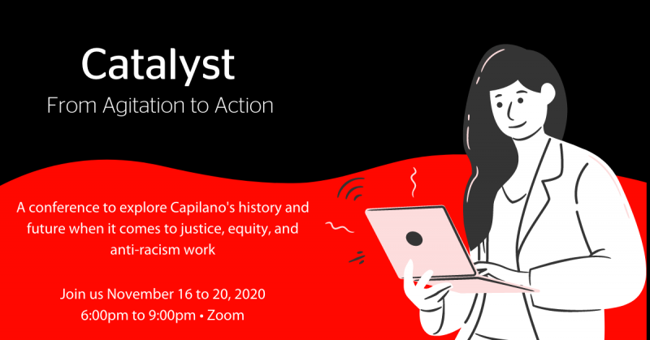
The Capilano Students’ Union is hosting a conference on anti-racism and anti-hate work during the week of November 16 to 20, 2020, from 6pm to 9pm. If you’re interested in presenting at the conference, please consider completing our call for presenters.

